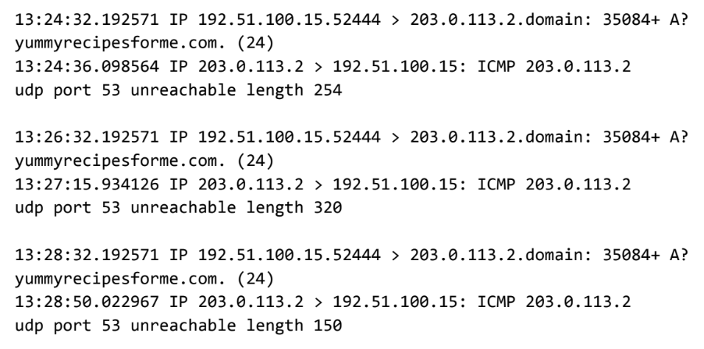

Part 1: Provide a summary of the problem found in the DNS and ICMP traffic log.
- The client sent mutliple requests (3) via the UDP protocal for a DNS resolution for the website yummyrecipiesforme.com, indicated by the A?, when trying to reach the website. Each time there was a response to the client, the ICMP protocal was used which is the protocal used when there is an error. The error states “udp port 53 unreachable length –“
Part 2: Explain your analysis of the data and provide at least one cause of the incident.
- Based on the information, the DNS server is down or unable to respond to the request. This is known because port 53 is used for DNS, meaning that the used port for resolving DNS requests is not reachable. More testing would have to be done to see if it’s offline, if there was a DoS attack, or a misconfiguration.

